**DataMart Creation on tutorial.flights on mode.com**​

**The output should contain all the attributes as different columns in the datamart created**​

​

Create a DataMart at airline level with different features like​

1. Total Number of flights​
2. Total Number of delayed flights (Based on arrival delay)​
3. Percentage of delayed flights​
4. Total Number of cancelled flights (All reasons)​
5. Percentage of cancelled flights​
6. Give Rank number to each airline based on percentage of delayed flights​
7. Give Rank number to each airline based on number of destinations it covers​
8. Add additional features which can help understand airlines better based on their performance

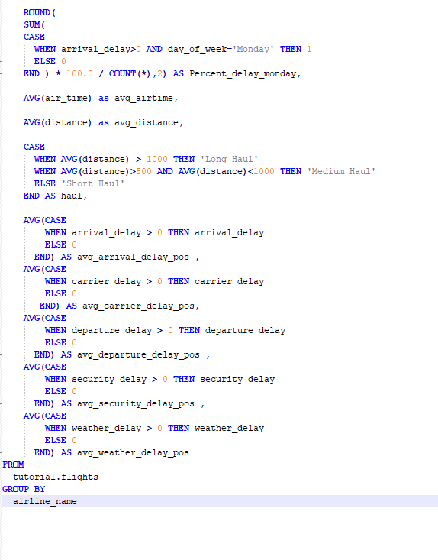

New Variables Created are :

* Early Arr Percent : This Variable indicates the percent of times airlines reached the destination earlier . If a aircraft reach earlier than its arrival time , airline would have to pay the airport extra Fess , which is a loss for airline.
* Percent delay Friday : This variable idicates the percent of time airlines got delayed on FRIDAY . Most of the people will be going to home town after work . So this would affect the passenger satisfaction.
* Percent delay Monday: This variable idicates the percent of time airlines got delayed on MONDAY.
* Average Airtime
* Average Distance
* Haul : Indicated whether the airline serve short routes or Long routes
* Average arrival delay: Average Minutes delayed at arrival.
* Average departure delay pos:Average minutes delayed at departure.
* Average security delay pos:Average minutes delayed due to security clearance.
* Average weather delay pos: Average minutes delayed due to weather.

SELECT

airline_name,

COUNT(airline_name),

COUNT(

CASE

WHEN arrival_delay > 0 THEN 1

ELSE NULL

END

) AS Delayed_Flights,

ROUND(

COUNT(

CASE

WHEN arrival_delay > 0 THEN 1

ELSE NULL

END ) * 100.0 / COUNT(*),2) AS Percent_delay,

COUNT(

CASE

WHEN was_cancelled =true THEN 1

ELSE NULL

END

) AS cancelled_flights,

ROUND(

COUNT(

CASE

WHEN was_cancelled = true THEN 1

ELSE NULL

END ) * 100.0 / COUNT(*),2) AS Percent_cancelled ,

DENSE_RANK() OVER( ORDER BY COUNT(

CASE

WHEN arrival_delay > 0 THEN 1

ELSE NULL

END ) * 100.0 / COUNT(*))AS rank_delay ,

DENSE_RANK() OVER(ORDER BY COUNT(DISTINCT(destination_airport))) AS Destination_rank,

ROUND(

COUNT(

CASE

WHEN arrival_delay < 0 THEN 1

ELSE NULL

END ) * 100.0 / COUNT(*),2) AS early_arr_Percent,

ROUND(

SUM(

CASE

WHEN arrival_delay>0 AND day_of_week='Friday' THEN 1

ELSE 0

END ) * 100.0 / COUNT(*),2) AS Percent_delay_friday,

ROUND(

SUM(

CASE

WHEN arrival_delay>0 AND day_of_week='Monday' THEN 1

ELSE 0

END ) * 100.0 / COUNT(*),2) AS Percent_delay_monday,

AVG(air_time) as avg_airtime,

AVG(distance) as avg_distance,

AVG(CASE

WHEN arrival_delay > 0 THEN arrival_delay

ELSE 0

END) AS avg_arrival_delay_pos ,

AVG(CASE

WHEN carrier_delay > 0 THEN carrier_delay

ELSE 0

END) AS avg_carrier_delay_pos,

AVG(CASE

WHEN departure_delay > 0 THEN departure_delay

ELSE 0

END) AS avg_departure_delay_pos ,

AVG(CASE

WHEN security_delay > 0 THEN security_delay

ELSE 0

END) AS avg_security_delay_pos ,

AVG(CASE

WHEN weather_delay > 0 THEN weather_delay

ELSE 0

END) AS avg_weather_delay_pos

FROM

tutorial.flights

GROUP BY

airline_name